**ANKARA UNIVERSITY**

**ENGINEERING FACULTY**

**DEPARTMENT OF COMPUTER ENGINEERING**



**REPORT I**

**Optical Character Recognition**

**Mustafa Ahmet DENİZ 14290087**

**Mustafa GÖKSEVER 14290099**

# **1. INTRODUCTION**

Optical character recognition (OCR) is a process of converting a printed document or scanned page into ASCII characters that a computer can recognise. Optical Character Recognition is broadly divided into two parts, offline recognition, and online recognition. Offline recognition deal with the system where the input is either an image or a scanned form of the document. In this paper, we are dealing with offline recognition technique.

Software Requirements:

1. Python

It is a high-level programming language which puts emphasis on code readability. Its user-friendly syntax assists in expressing concepts in fewer lines of code.

2. OpenCV (Open Source Computer Vision)

It is a library of programming functions mainly aimed at real-time computer vision, which is the field of processing and analyzing digital images.

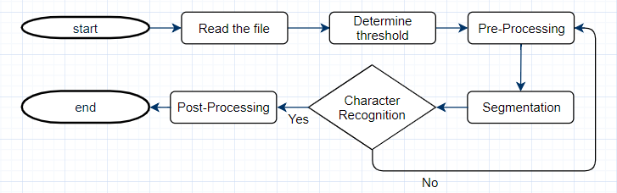

Figure 1.1. OCR Flow

# **2. OCR METHODOLOGY**

There are three basic processes on which OCR works: Preprocessing, Segmentation and Character Recognition.

## **2.1 Browse**

In this step, we store the path of the chosen image from the browse menu. Chosen image was read by cv2.imread() method. All file formats which is .png, .jpg etc. are supported.

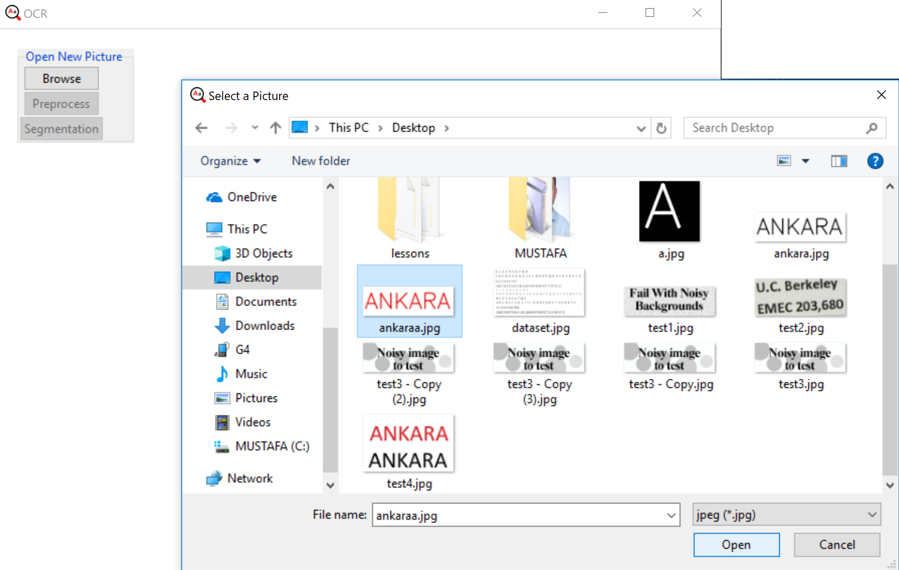

Figure 2.1. Browse Menu

## **2.2. Preprocessing**

There could be some noise, outlier object that affects the accuracy of text recognized through OCR. In order to achieve higher recognition rate, preprocessing algorithms makes the OCR system more robust by accurate image enhancement, noise removal, image thresholding, skew detection/correction

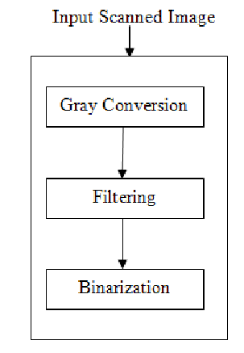

Figure 2.2. Preprocess Steps

### **2.2.1. Gray Conversion**

Grayscale images have many shades of gray. For achieving accuracy input document should be grayscale. To convert a color from a color space based on an RGB color model to a grayscale representation following function is used

**Y = 0.2126R+0.7152G+0.0722B**

When the preprocess button was pressed, this chosen image was converted to gray image by cvtColor() method. In this method converts an input image from one color space to another. COLOR_BGR2GRAY was used in our project. After the calculation gray image was shown.

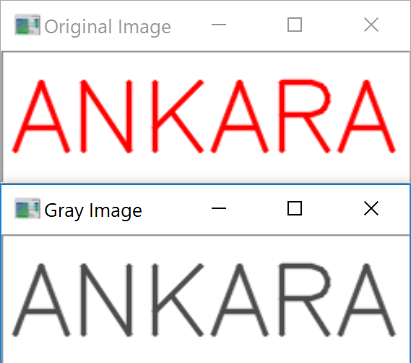

Figure 2.3. Original Image and Gray Image

### **2.2.2. Blurring**

We can see that the image above needs further enhancement, therefore, we apply another blur to improve the looks.

-cv2.GaussianBlur()

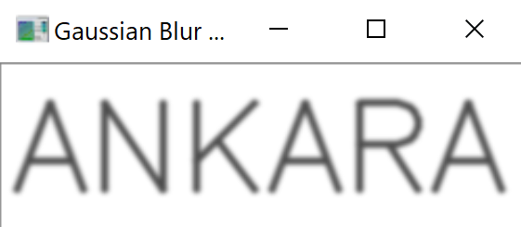

Figure 2.4. Gaussian Blur Image

### **2.2.3. Binarization**

This step converts a multicolored image (RGB) to a black and white image. There are several algorithms to convert a color image to a binary image, ranging from simple thresholding to more sophisticated zonal analysis.

If the pixel value is greater than a threshold value, it is assigned 0, else it is assigned 256. We applied thresholding with value 127 using cv2.threshold() method.

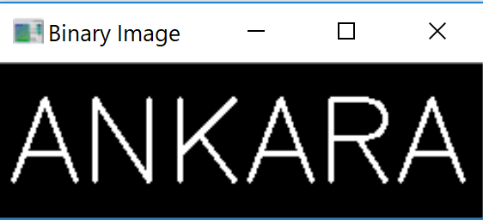

Figure 2.5. Binary Image

Preprocess is done. Now segmentation button is available to press.

## **2.3. SEGMENTATION**

Segmentation partitions an image into distinct regions containing each pixel with similar attributes. To be meaningful and useful for image analysis and interpretation, the regions should strongly relate to depicted objects or features of interest.

-cv2.findContours()

When the segmentation button was pressed, Contours in the binary image was found and drawn a green rectangle around the characters one by one. After that contours were sorted from left to right.

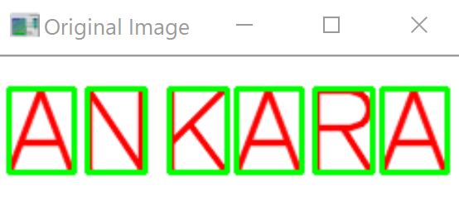

Figure 2.6. Finding Contours

After that contours were sorted from left to right. Characters were found and saved in IMAGEROI Folder. It’s shown below.

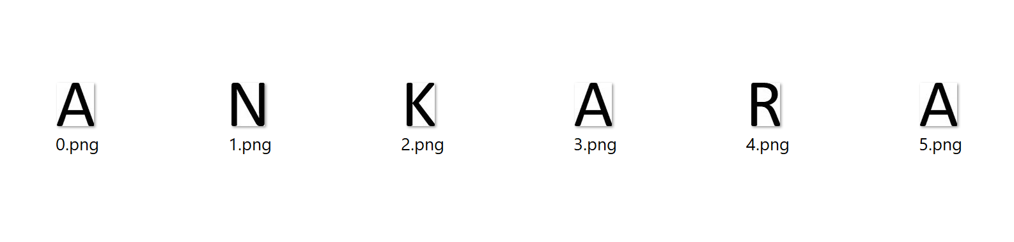

Figure 2.7. Located Characters

# **3. CHARACTERS RECOGNITION**

cv2.matchTemplate()

Template matching is a method that checks how much two images are similar to each other. Template matching works by "sliding" the template across the original image. As it slides, it compares or matches the template to the portion of the image directly under it. This method calculates all the correlation coefficients for every displacement between the input images. After the template matching, you can filter the results by the decent threshold, let’s say 0.85, to check if the images are similar (this threshold depends on your input images, e.g. lightning, different sensor types etc.), then look for the max value displacement.

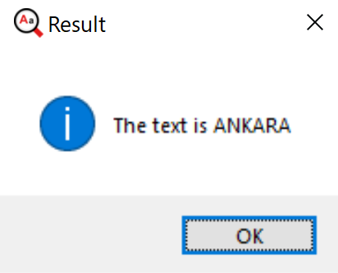

Figure 3.1. The resulting text from image

**FUTURE WORKS**

Applications of our approach are varied. We hope to implement our ideas further on the various image for multiple fonts, lower case, and different size. The development of OCR to directly using machine learning algorithm which is known KNN is also something we would like to pursue in the near future.

**CONCLUSION**

We have shown that matching template can be implemented successfully in optical character recognition. Image processing with OCR has some steps like preprocessing, segmentation and recognition. In the preprocessing phase, it was aimed to increase the text recognition accuracy by making reduce the noise and threshold. In the segmentation phase, contours in the binary image were found and drawn a green rectangle around the characters one by one. And in recognition phase, contours matched with dataset using matchTemplate() method.